STAT 8670 PROJECT

AGEING POPULATION GROWTH ANALYSIS USING BAYESIAN INFERENCE

Li Sun

**1. Objective**

The world is getting older by the minute. It is set to become one of the most consequential social alterations in the age of humankind. In this project, a data set (from data.worldbank.org) containing population ages 65 and above as a ratio of the total population for 269 countries was analyzed. After omitting the empty observations, there were a total of 237 countries left in the final data model. The comparison of ageing population ratio change globally between the first 2 years in the data set, which were the years of 1960 and 1961, and between the latest 2 years 2016 and 2017 was simulated. Since the model parameters were random variables, Bayesian inference as a feasible approach was implemented. Furthermore, in Bayesian statistics, since Markov chain Monte Carlo (MCMC) methods has been a key step in making it possible to compute large hierarchical models, MCMC method was utilized in the work. At the same time, Metropolis-Hastings algorithm, a specific implementation of MCMC, was performed to compute the distribution over the parameters.

The questions were formulated as:

• Is the mean of ageing population ratio in year 1961 greater than the mean of ageing population ratio in year 1960? If so, how much?

• Is the mean of ageing population ratio in year 2017 greater than the mean of ageing population ratio in year 2016? If so, how much?

• Is the mean of ageing population ratio in year 2017 greater than the mean of ageing population ratio in year 1960? If so, how much?

**2. Computational Method Introduction**

**2.1 Bayesian inference**

Bayesian inference is closely related to probability. It manipulates priors, evidence, and likelihood to computer posterior. It consists of the following elements:

* prior: P($θ$)

represents how likely the parameter ($θ$) is

* likelihood: P( D | )

represents how likely is data (D) for given parameter ($θ$)

* evidence: P(D)

represents how likely data (D) is

* posterior: P( | D)

represents the most likely distribution of parameter ($θ$)of the model explaining the data (D)

P( | D) = $\frac{P(θ)*P( D | θ)}{P(D)}$

posterior P( | D) is proportional to prior P($θ$) * likelihood P( D | )

**2.2 Markov Chain Monte Carlo (MCMC)**

MCMC allows us to draw samples from a distribution even if we cannot compute it. It can be used to compute the distribution over the parameters given a set of observations and a prior belief.

**2.3 Metropolis-Hastings Algorithm**

Metropolis-Hastings is a specific implementation of MCMC. It works well in high dimensional spaces in sampling and rejection sampling.The Metropolis-Hastings algorithm does the following:

* given

1. f, the PDF of the distribution to sample from
2. Q, the transition model
3. $θ{}_{0}$, a first guess for $θ$
4. $θ$ = $θ{}_{0}$

* for n iterations

1. *p = f(D|)P($θ$)*
2. $θ^{'}$*= Q($θ_{i}$)*
3. $p^{'}$ = f($D|Θ= θ^{'})P(θ^{'})$
4. ratio = $p^{'}$/ $p$
5. generate a uniform random number r in [0,1]
6. if r < ratio, set $θ_{i}$*= $θ^{'}$*

**3. Data Analysis**

**3.1 Computational method implementation**

The histograms of ratios in 1960 and 1961 are given below:

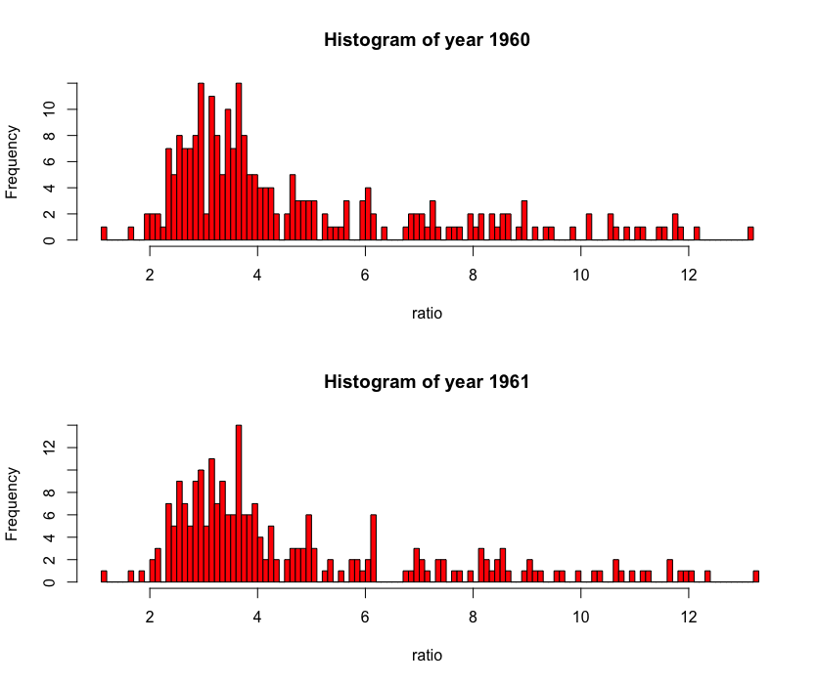

The histograms of ratios in 2016 and 2017 are given below:

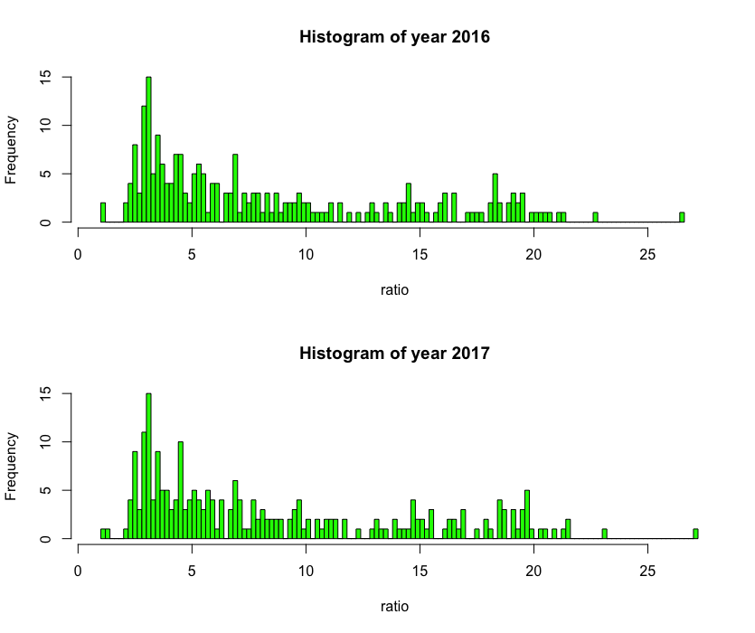

The conclusion is not so obvious from histograms. But it is not hard to see that all of them are right-skewed distribution. I assumed that the ratio in each year followed gamma distribution $Γ$*(a,b)*, here *a* is shape parameter, and *b* is scale parameter. The ratio in pre-year (1960 or 2016) comes from $Γ(a_{1}, b_{1})$ and the tatio in pos-year (1961 or 2017) comes from $Γ(a_{2}, b_{2})$. So the parameter vector is $θ=(a_{1}, b_{1}a_{2},b_{2})$*.*One important point that has to be emphasized is that the mean of a gamma distribution is *a * b*.

I constructed a likelihood function and a prior function, and then multiplied them together to get posterior *P(θ|Data)*. In my case, multiplying hundreds of small values caused an underflow in the system memory. In order to keep numerical stability, I used ***log*** on both the prior and the likelihood functions.

**3.1.1 Likelihood function**

Let x denotes the ratio in pre-year and let y denotes the ratio in pos-year. Since *xi*and *yj*are independent for *i = 1,2, …, 237* and *j = 1,2,..., 237*, the likelihood function is written by the formula

* likelihood: P( D | )

*P( D|) = P(x|)* P(y|*

= 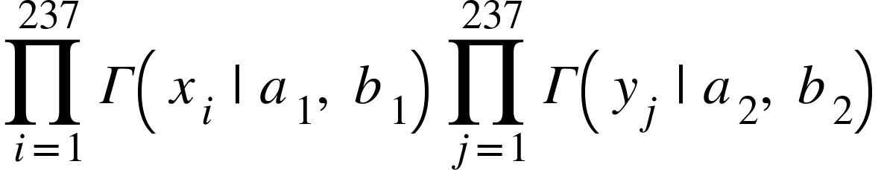= 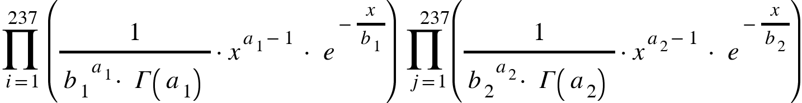

* log(*Likelihood):*

*log( P( D|)) = log (P(x|)* P(y|)*

*= sum((a1-1)*log(xi) - (1/b1)*pre - a1*log(b1) - log(gamma(a1))) +*

*sum((a2-1)*log(yj**) - (1/b2)*pre - a2*log(b2) - log(gamma(a2)))*

**3.1.2 Prior function**

As for the decision on a prior density for *θ = (a1, b1, a2, b2)*, the basic thinking is simply to choose priors for the *mu1 = a1*b1* and *mu2 = a2*b2*that do not seem to prejudge which is big, and to choose priors that are sort of uniformish over all even remotely plausible values, with the aim of letting the data produce any interesting features in the posterior distribution. I chose the distribution of all 4 parameters as normal distribution, that is *a1~ N(a01, a01), b1~ N(b01, b01), a2~ N(a02, a02) and b2~ N(b02, b02).* I chose the distributions liked this because I wanted the distribution as flat as possible, otherwise the prior would control the posterior.

Then the prior is given by

* prior: P($θ$)

P($θ$) = P($a_{1}$, $b_{1}$, $a_{2}$, $b_{2}$) = P($a_{1}$)*P( $b_{1}$)*P($a_{2}$)* P($b_{2}$)

= 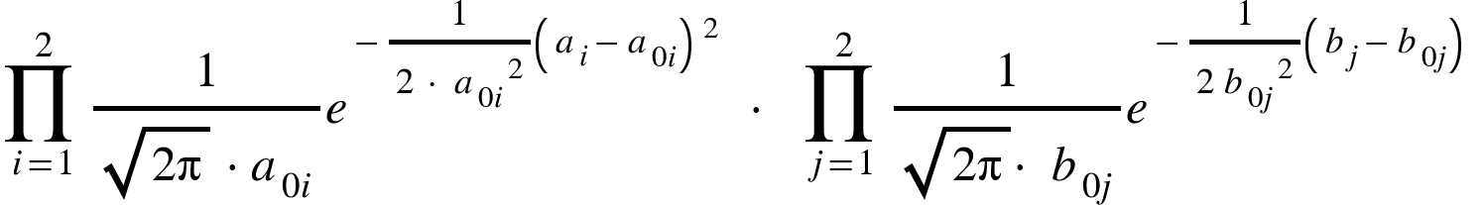

* log(prior: P($θ$) )

log(P($θ$)) = log (P($a_{1}$)*P( $b_{1}$)*P($a_{2}$)* P($b_{2}$))

= -log(a01*sqrt(2*pi)) - ((a1-a01)^2/(2*a01^2))

-log(b01*sqrt(2*pi)) - ((b1-b01)^2/(2*b01^2))

-log(a02*sqrt(2*pi)) - ((a2-a02)^2/(2*a02^2))

-log(b02*sqrt(2*pi)) - ((b2-b02)^2/(2*b02^2))

**3.1.3 Posterior function**

Next, posterior is obtained by multiplying prior and likelihood. And log posterior is the sum of the log prior and log likelihood.

* posterior P( | D)

P( | D) = prior P($θ$) * likelihood P( D | )

* log(posterior P( | D) )

Log (P( | D)) = log (P($θ$)) + log(P( D | ) )

**3.1.4 Metropolis-Hastings Algorithm manipulation**

In the project, and in both cases, the initial parameters were randomly assigned as *a01=10, b01=3, a02=11, and b02=5.* A Markov chain using Metropolis for 50,000 iterations was performed to simulate a sample. Given a current state, a way to propose a ‘candidata’ move have to be decided. Then the log posterior of candidate move and the log posterior of current state are compared. Due to the log algorithm, exponentiation is used to compare to the random number in acception and rejection samplings. The results are recorded in a big matrix with 4 columns and 50000 rows. The first row is the starting value and each successive row record the next θ as the chain runs.

**3.2 Result interpretation**

**3.2.1 data Analysis and interpretation**

Now we have gotten a bunch of parameter vectors. Let’s first take a look at how the chain ran. The traces for parameters in 1960 and 1961 are given below.

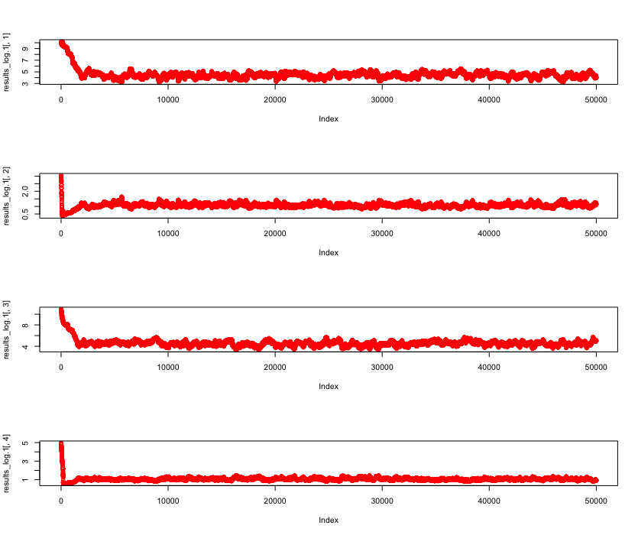

The traces for parameters in 2016 and 2017 are given below:

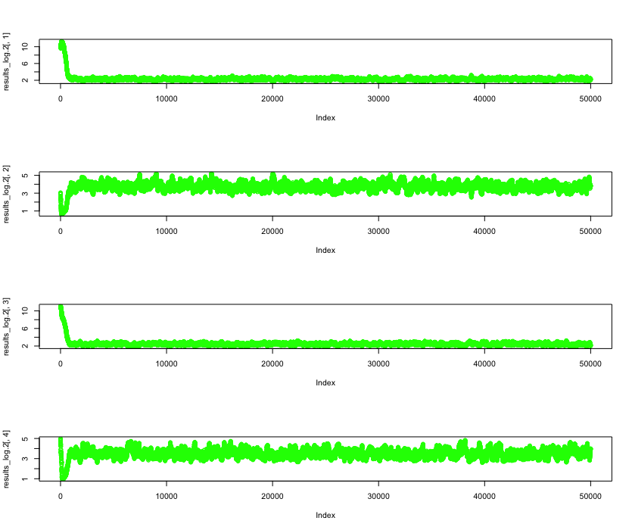

It looks like the beginning iterations may be noticeably influenced by the starting values. Then I threw away the first 25% of iterations as ‘burn-in’ and let the remaining be the new results. In this way, the inferences were based on the new results instead of the whole results matrix. The new MCMC sampling without ‘burn in’ are shown below. The parameter histograms indicate that the normality assumption of initial parameters for prior function is reasonable and acceptable.

The traces of parameters without ‘burn-in’ and their corresponding histograms in 1960 and 1961 are given by

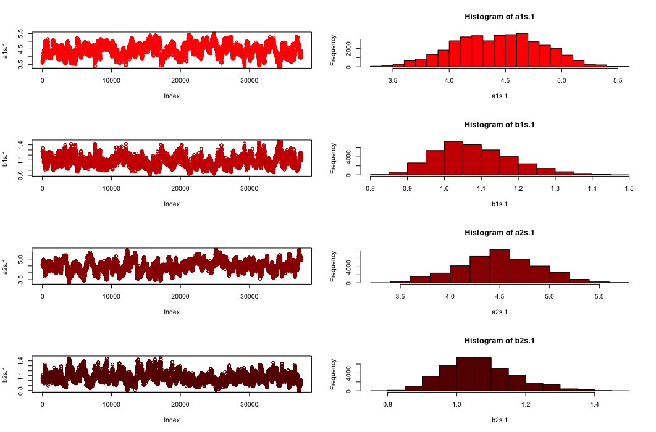

The traces of parameters without ‘burn-in’ data and their corresponding histograms in 2016 and 2017 are given by

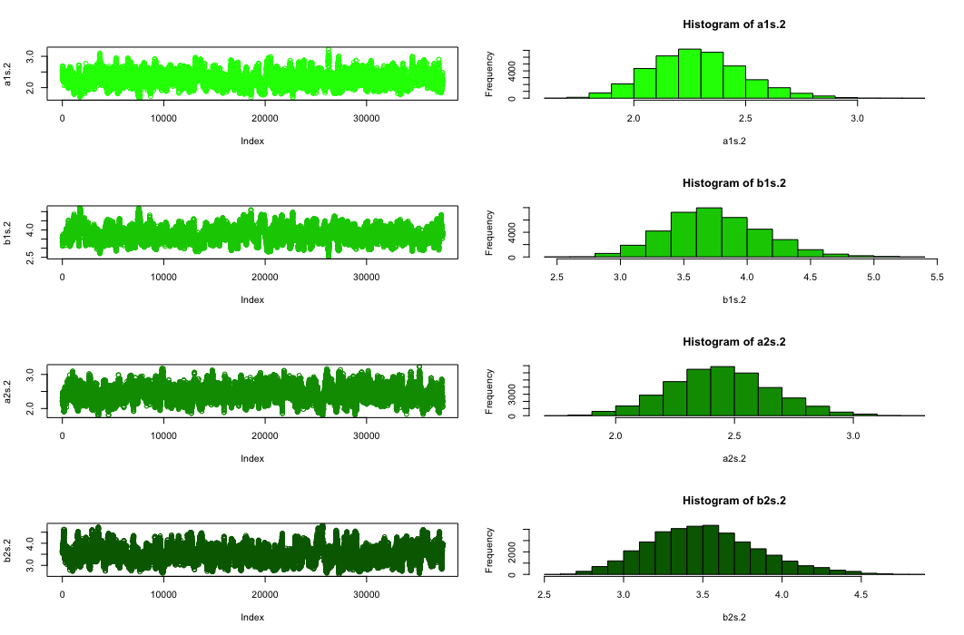

Based on the estimated posterior, the mean difference between the pre-year and pos-year were computed.

The plot and histogram of the mean difference between 1960 and 1961 are posted as

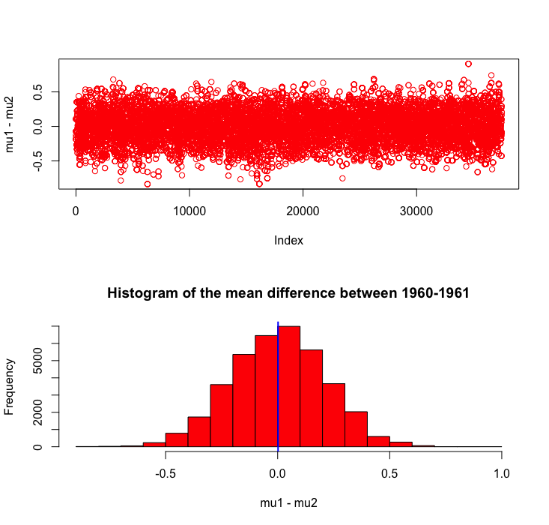

The plot and histogram of the mean difference between 2016 and 2017 are posted as

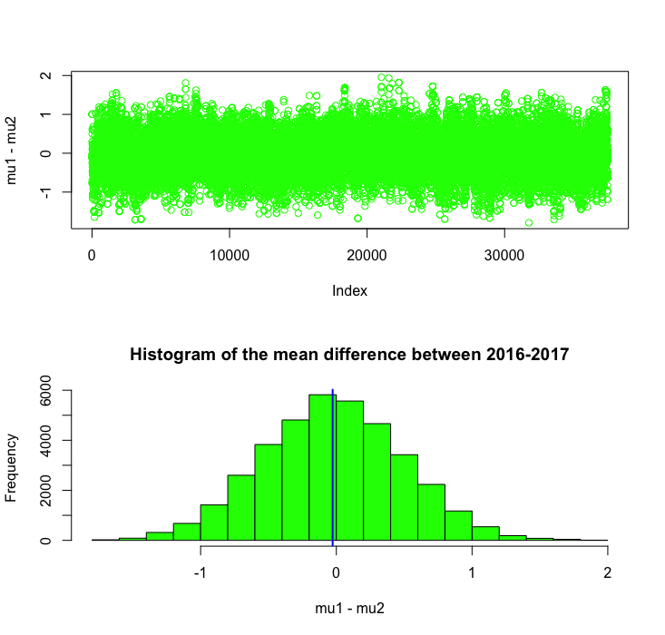

The plot and histogram of the mean difference between 1960 and 2017 are posted as

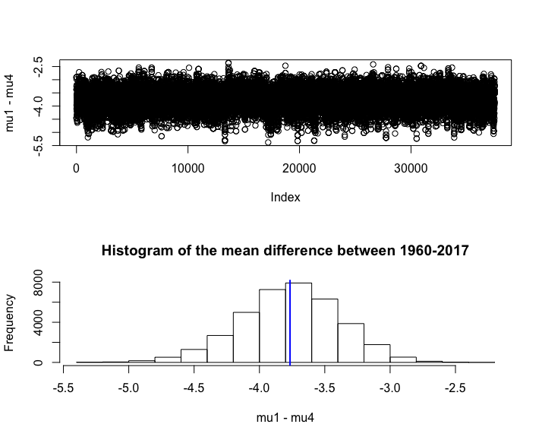

The estimated posterior probabilities that *mu1 - mu2 < 0* are 0.487, 0.522 and 1 for years 1960 and 1961, years 2016 and 2017, and years 1960 and 2017 respectively. Thus the probability that the mean of ageing population ratio in year 1961 higher than 1960 is slightly lower than 0.5. In contrast, the probability that the mean of ageing population ratio in year 2017 higher than 2016 is slightly greater than 0.5. There is no surprise that the mean of ageing population ratio would increase dramatically during the past 57 years from 1960 to 2017, however it is still astonishing that the probability is 100% for sure that the mean of ageing population ratio in year 2017 is higher than 1960.

*.*

**3.2.2 Example analysis for year 1960**

In this project, I explored more detail on the simulated parameter data in year 1960. The starting value for shape *a* is *10*, and for scale *b* is *3*. The MCMC Metropolis-Hastings algorithm accepted 7598 pairs of samples and rejected 42403 pairs of samples. The average of value without burn-in for shape *a* is *4.39136*, and for scale *b* is *1.08786,* which are pretty far off the initial values.

The plots of MCMC sampling for a and b with Metropolis-Hastings illustrate how the algorithm worked its way to the parameters. In these plots, the accepted samples are presented in blue lines, and rejected samples are marked as red dots.

As we can see from the figures, the algorithm converges to the zone around [*a = 4.4*, *b = 1.1*].

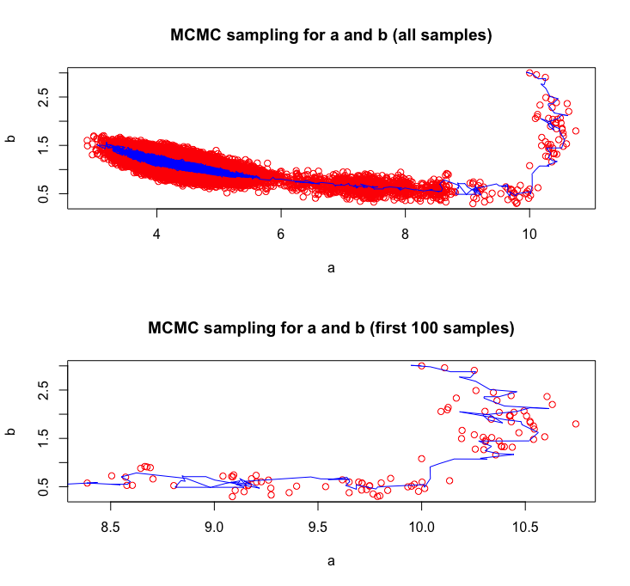

The traces of a and b, and the histogram of the traces are shown below.

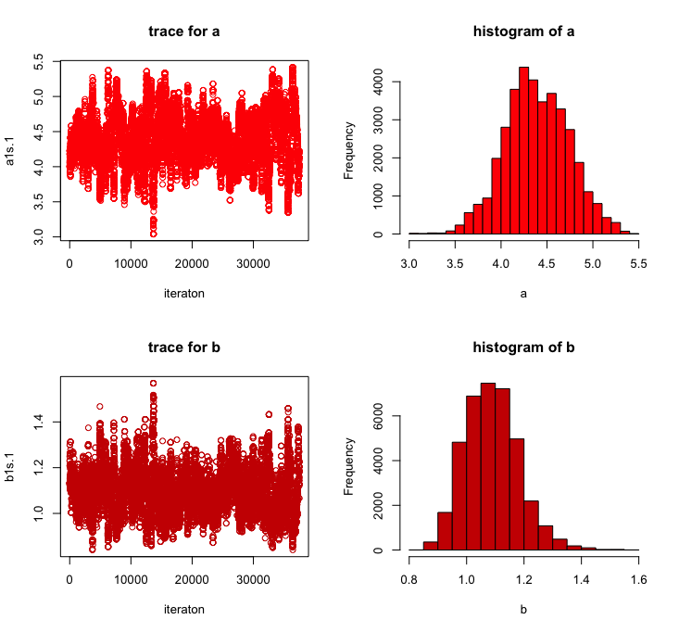

The prediction of the distribution of ageing population ratio in year 1960 with a gamma distribution $Γ(a =4.39136, b = 1.08786)$ are graphed below. It indicates that proposal gamma distribution works fine in this case.

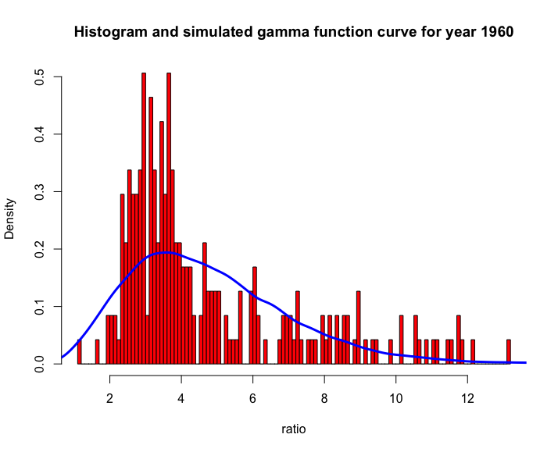

**4. Conclusion**

According to our discussion above, we get the conclusion that

• The mean of ageing population ratio in year 1961 is slightly less than the mean of ageing population ratio in year 1960. The probability of *mean(1961) > mean(1960)* is 0.49.

• The mean of ageing population ratio in year 2017 is slightly greater than the mean of ageing population ratio in year 2016. The probability of *mean(2017) > mean(2016)* is 0.52.

• The mean of ageing population ratio in year 2017 is definitely greater than the mean of ageing population ratio in year 1960. The probability of *mean(2017) > mean(1960)* is 1.

Thus overall, the change in the ratio of the population ages 65 and above over the total population between 1961 and 1960 decreases slightly, and the change in ratio increases slightly from 2017 to 2016. When taking a long term view, the change in the ratio between 2017 and 1960 increases certainly.

**5. Reference**

1. Dr. Jing Zhang’s lecture notes.
2. Wei Gao’s project sample

**6. R Code**

--------------------------------------------------------------------------------------

Chapter 3.1 Computational method implementation

--------------------------------------------------------------------------------------

###################################

##### read in and process data set #####

###################################

|  |
| --- |
| dat=read.csv('/Users/lisun/GSU/Computational/finalproject/datasets/Population_age65+/API_SP.POP.65UP.TO.ZS_DS2_en_csv_v2_10517738.csv', header = F, row.names = 1 )   #### clean data # str(dat) # 267 obs. of 63 variables data1 = dat[-c(1:2), -c(1:3,63)]  colnames(data1) = as.character(unlist(data1[1,])) # name column names data1 = data1[-1, ] # remove column name row  data1 = data1[, -59] # remove last empty column year 2018  # remove the variables with missing values  id_no_miss = which(apply(is.na(data1),1,sum)==0) data= data1[id_no_miss,] # str(data) # 237 obs. of 58 variables |

############################

##### Bayesian Inference ######

############################

### log likelihood function

|  |
| --- |
| lik_log = **function**(th, pre, pos) { a1=th[1] ; b1=th[2] ; a2=th[3] ; b2=th[4]   sum((a1-1)*log(pre)-(1/b1)*pre - a1*log(b1) - log(gamma(a1))) +  sum((a2-1)*log(pos)-(1/b2)*pre - a2*log(b2) - log(gamma(a2)))} |

### log prior function

|  |
| --- |
| prior_log = **function**(th, th0) {  a1=th[1] ; b1=th[2] ; a2=th[3] ; b2=th[4]  a01 = th0[1]; b01 = th0[2]; a02 = th0[3]; b02 = th0[4]  **if** (a1 <= 0 | a2 <= 0 | b1 <= 0 | b2 <= 0 )  {**return**(0)}**else**  { result =  -log(a01*sqrt(2*pi)) -((a1-a01)^2/(2*a01^2))  -log(b01*sqrt(2*pi)) -((b1-b01)^2/(2*b01^2))  -log(a02*sqrt(2*pi)) -((a2-a02)^2/(2*a02^2))  -log(b02*sqrt(2*pi)) -((b2-b02)^2/(2*b02^2))  **return**(result)  }  } |

### log posterior function

|  |
| --- |
| post_log = **function**(th, th0,pre, pos){prior_log(th, th0) + lik_log(th, pre, pos)} |

### MCMC (Metropolis method):

|  |
| --- |
| my.MCMC = **function**(nit, th0, pre, pos) {  th = th0  results_log = matrix(0, nrow=nit , ncol=4)   accepted_log = matrix(th0, nrow=1 , ncol=4)   rejected_log = matrix(th0, nrow=1 , ncol=4)   results_log[1,] = th0   initial.time = proc.time()  **for**(it **in** 2:nit)  {  cand = th + rnorm(4, mean = 0, sd=0.1)   res = post_log(cand,th0, pre,pos) - post_log(th,th0, pre,pos)  **if** (runif(1) < exp(res))  {  th=cand  accepted_log = rbind(accepted_log, cand)  }**else**  {  rejected_log = rbind(rejected_log, cand)}  results_log[it,] = th  }  time = proc.time() - initial.time; time   my_list = list('results_log'= results_log, 'time' = time)  **return**(my_list) } |

------------------------------------------------------------------------------

Chapter 3.2.1 data Analysis and interpretation

-------------------------------------------------------------------------------

#### Starting values

|  |
| --- |
| a01 = 10; b01 = 3; a02 = 11; b02 = 5 th0=c(a01, b01 ,a02, b02) nit=50000 |

#################################

#### compare the first 2 years #####

#### year 1960 and year 1961 #####

#################################

|  |
| --- |
| pre.1 = data[,1] pos.1 = data[,2] |

### draw a picture

|  |
| --- |
| xlim =c(min(pre.1),max(pre.1))  par(mfrow=c(2 ,1))  hist (pre.1,breaks = 100 , col='red',xlim=xlim, main = 'Histogram of year 1960', xlab = 'ratio') hist (pos.1,breaks = 100 , col='red',xlim=xlim, main = 'Histogram of year 1961', xlab = 'ratio') |

### Call MCMC function

|  |
| --- |
| result.1 = my.MCMC(nit = nit, th0 = th0, pre = pre.1, pos = pos.1)  results_log.1 = result.1$results_log time.1 = result.1$time; time.1  [1] 22.004 |

### Take a peek at what we got edit (results)

|  |
| --- |
| par(mfrow=c(4 ,1))  plot (results_log.1 [ ,1], col = 'red') ; plot(results_log.1 [ ,2], col ='red') ; plot (results_log.1 [ ,3], col = 'red') ; plot(results_log.1 [ ,4], col = 'red') |

### omit burn-in data

|  |
| --- |
| res=results_log.1[(0.25*nit):nit,]  a1s.1 = res[,1];b1s.1 = res[,2] ;a2s.1 = res[,3];b2s.1 = res[,4] |

### plot and histogram

|  |
| --- |
| par(mfrow=c(4 ,2))  plot (a1s.1, col = rgb(1,0,0)) ;hist(a1s.1, col = rgb(1,0,0)) plot (b1s.1, col = rgb(0.8,0,0)) ;hist(b1s.1, col = rgb(0.8,0,0)) plot (a2s.1, col = rgb(0.6,0,0)) ;hist(a2s.1, col = rgb(0.6,0,0)) plot (b2s.1, col = rgb(0.4,0,0)) ;hist(b2s.1, col = rgb(0.4,0,0)) |

### compare the mean difference between the first 2 years

|  |
| --- |
| par(mfrow=c(2 ,1))  mu1 = a1s.1*b1s.1; mu2 = a2s.1*b2s.1 plot (mu1-mu2,col = 'red')  hist (mu1-mu2, main = 'Histogram of the mean difference between 1960-1961', col = 'red')  abline(v = mean(mu1-mu2), col = 'blue',lwd = 2) mean((mu1-mu2) < 0)  [1] 0.4869203 |

#################################

#### compare the last 2 years #####

#### year 2016 and year 2017 #####

#################################

|  |
| --- |
| pre.2 = data[,57] pos.2 = data[,58] |

### draw a picture

|  |
| --- |
| xlim =c(min(data),max(data))  par(mfrow=c(2 ,1))  hist (pre.2,breaks = 100 , col='green',xlim=xlim, main = 'Histogram of year 2016', xlab = 'ratio') hist (pos.2,breaks = 100 , col='green',xlim=xlim, main = 'Histogram of year 2017', xlab = 'ratio') |

### Call MCMC function

|  |
| --- |
| result.2 = my.MCMC(nit = nit, th0 = th0, pre = pre.2, pos = pos.2)  results_log.2 = result.2$results_log time.2 = result.2$time; time.2  [1] 31.389 |

### Take a peek at what we got edit (results)

|  |
| --- |
| par(mfrow=c(4 ,1))  plot(results_log.2[,1], col = 'green');plot(results_log.2[,2],col = 'green'); plot(results_log.2[,3], col = 'green');plot(results_log.2[,4],col = 'green') |

### omit burn-in data

|  |
| --- |
| res=results_log.2 [(0.25*nit):nit,]  a1s.2 = res[,1];b1s.2 = res[,2] ;a2s.2 = res[,3];b2s.2 = res[,4] |

### plot final data set and its histogram

par(mfrow=c(4 ,2))   
plot(a1s.2, col = rgb(0,1,0));hist(a1s.2, col = rgb(0,1,0))  
plot(b1s.2, col = rgb(0,0.8,0));hist(b1s.2, col = rgb(0,0.8,0))  
plot(a2s.2, col = rgb(0,0.6,0));hist(a2s.2, col = rgb(0,0.6,0))  
plot(b2s.2, col = rgb(0,0.4,0)) ;hist(b2s.2, col = rgb(0,0.4,0))

### compare the mean difference between the last 2 years

|  |
| --- |
| par(mfrow=c(2 ,1))  mu1 = a1s.2*b1s.2; mu2 = a2s.2*b2s.2 plot (mu1-mu2,col = 'green')  hist (mu1-mu2, main = 'Histogram of the mean difference between 2016-2017', col = 'green')  abline(v = mean(mu1-mu2), col = 'blue',lwd = 2) mean((mu1-mu2) < 0)  [1] 0.5220927 |

########################################

##### compare the first and last years #####

##### year 1960 and year 2017 #####

########################################

# plot and Histogram of the mean difference between 1960-2017

|  |
| --- |
| par(mfrow=c(2 ,1))  mu1 = a1s.1*b1s.1; mu4 = a2s.2*b2s.2 plot (mu1-mu4)  hist (mu1-mu4, main = 'Histogram of the mean difference between 1960-2017')  abline(v = mean(mu1-mu4), col = 'blue',lwd = 2) mean((mu1-mu4) < 0) |

------------------------------------------------------------------------------

Chapter 3.2.2 Example analysis for year 1960

-------------------------------------------------------------------------------

#######################################

###### data analysis for year 1960 ######

#######################################

### algorithm for sampling

|  |
| --- |
| accepted = result.1$accepted_log rejected = result.1$rejected_log nrow(accepted) [1] 7598 nrow(rejected) [1] 42403 |

### calculate the simulated estimators

|  |
| --- |
| a1.1 = mean(a1s.1);a1.1  [1] 4.39136 b1.1 = mean(b1s.1);b1.1   [1] 1.08786 |

### plot data sampling

|  |
| --- |
| plot(rejected[,1], rejected[,2], type = 'p', col = 'red',   main = 'MCMC sampling for a and b (all samples)', xlab = 'a', ylab = 'b' ) lines(accepted[,1],accepted[,2], type = 'l', col = 'blue') plot(rejected[1:100,1], rejected[1:100,2], type = 'p', col = 'red',  main = 'MCMC sampling for a and b (first 100 samples)', xlab = 'a', ylab = 'b') lines(accepted[1:100,1],accepted[1:100,2], type = 'l', col = 'blue') |

### the traces of a and b and the histogram of the traces

|  |
| --- |
| par(mfrow=c(2 ,2)) plot (a1s.1, col = rgb(1,0,0), main = 'trace for a',xlab = 'iteration')  hist(a1s.1, col = rgb(1,0,0), main = 'histogram of a', xlab = 'a') plot (b1s.1, col = rgb(0.8,0,0),main = 'trace for b',xlab = 'iteration')  hist(b1s.1, col = rgb(0.8,0,0),main = 'histogram of b', xlab = 'b') |

### Histogram and gamma function curve

|  |
| --- |
| xlim = c(min(pre.1), max(pre.1)) hist (pre.1,col= rgb(1,0, 0),xlim=xlim, breaks = 100, prob = T,   main = 'Histogram and simulated gamma function curve for year 1960', xlab = 'ratio')  x = rgamma(nit, shape = a1.1, scale = b1.1) d = density(x) lines(d$x,d$y,col = 'blue', type = 'l', lwd = 3) |